**DAILY ONLINE ACTIVITIES SUMMARY**

|  |  |  |  |  |  |  |  |
| --- | --- | --- | --- | --- | --- | --- | --- |
| **Date:** | **29/05/2020** | | | | **Name:** | **Imran Khan** | |
| **Sem & Sec** | **8th A** | | | | **USN:** | **4AL16CS040** | |
| **Online Test Summary** | | | | | | | |
| **Subject** | | **BDA** | | | | | |
| **Max. Marks** | | **30** | | **Score** | | **21** | |
| **Certification Course Summary** | | | | | | | |
| **Course** | **AWS training** | | | | | | |
| **Certificate Provider** | | | **AWS** | **Duration** | | | **90minutes** |
| **Coding Challenges** | | | | | | | |
| Problem Statement: Write a C Program to generate first N Armstrong Numbers. | | | | | | | |
| **Status: Solved** | | | | | | | |
| **Uploaded the report in Github** | | | | **yes** | | | |
| **If yes Repository name** | | | | **Imran040** | | | |
| **Uploaded the report in slack** | | | | **yes** | | | |

**Online Test Details:**

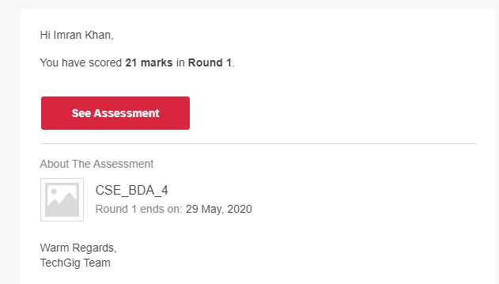

**Certification Course Details**:

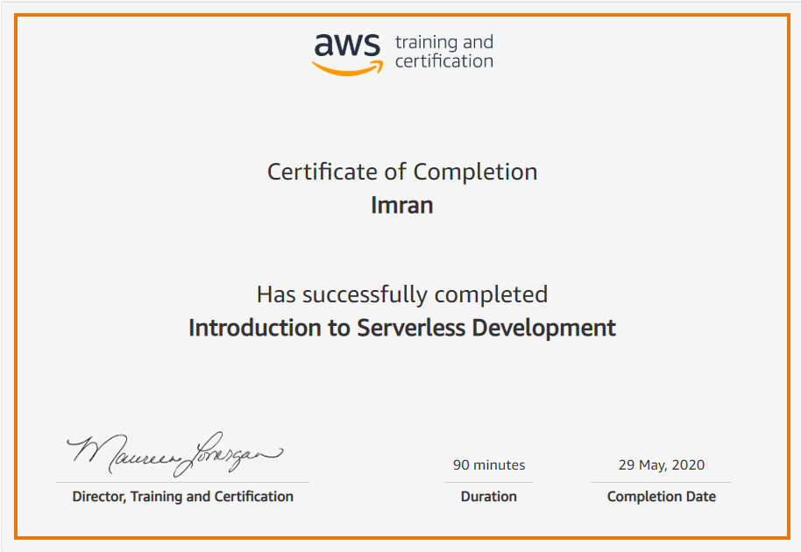

**Coding Challenges Details**:

**program1:**

|  |
| --- |
|  |
| #include<stdio.h> | |
|  | |  |
|  | | void main() |
|  | | { |
|  | | int n,num = -1,remainder,sum,x; |
|  | |  |
|  | | printf("Enter a number: \n"); |
|  | | scanf("%d",&n); |
|  | |  |
|  | | printf("Armstrong numbers are:\n"); |
|  | |  |
|  | | while(n!=0) |
|  | | { |
|  | | num++; |
|  | | x=num; |
|  | | sum=0; |
|  | | while(x!=0) |
|  | | { |
|  | | remainder=x%10; |
|  | | sum=sum+remainder*remainder*remainder; |
|  | | x=x/10; |
|  | | } |
|  | | if(sum==num) |
|  | | { |
|  | | printf("%d\n",num); |
|  | | n--; |
|  | | } |
|  | | } |
|  | | } |